City of Lakewood
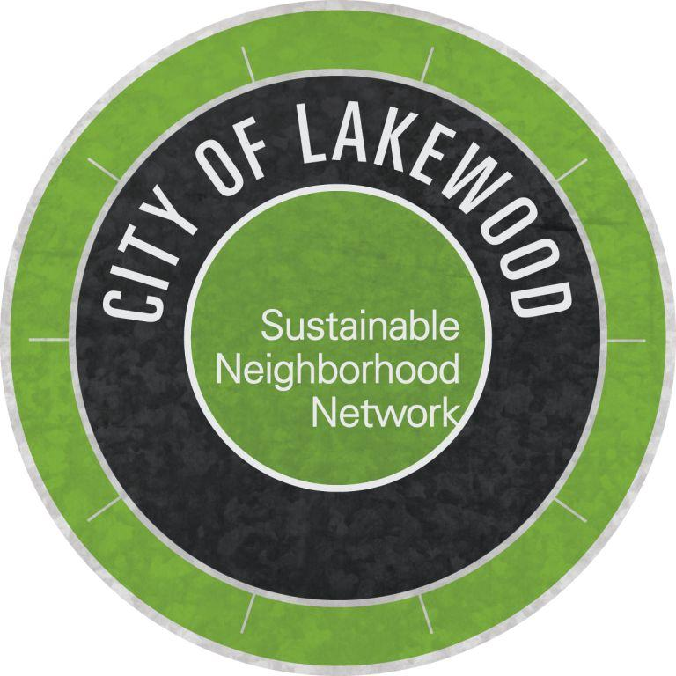

SUSTAINABLE NEIGHBORHOODS PROGRAM
- 2026 APPLICATION GUIDE –

Use this guide to prepare answers for your neighborhood’s Sustainable Neighborhood Program online application (available at SustainableNeighborhoodNetwork.org/Lakewood).
Applications are due by Monday, March 2, 2026. Contact Christy Cerrone at ChristyCerrrone@lakewoodCO.gov if you need assistance or have questions.

1. Applicant Information
Select a primary contact for your application and provide the following information:

- Primary Applicant Name
- Address
- Phone Number
- Email

2. Application Team Information
  - Please list the names and email addresses of co-applicants and secondary contacts who would like to participate in the Sustainable Neighborhood leadership team. (More people will be added throughout Sustainable Neighborhood launch process and meetings; meanwhile, we're interested in hearing who is involved on the team now.)

3. Neighborhood Interest and Understanding of the Program
- What is your understanding of the purpose and function of the Sustainable Neighborhoods Program?
- Why are you interested in your neighborhood being a part of the Sustainable Neighborhoods Program?

4. Neighborhood Boundaries and Map
- Use streets or landmarks to describe boundaries of your neighborhood. Note: the boundaries of neighborhoods can be flexible. Some of our current Sustainable Neighborhooods are identified by a pre-existing neighborhood organization or homeowner's association. Some neighborhoods are identified by certain geography or streets that border the neighborhood. Some neighborhoods have a pre-existing neighborhood name, and some are brand new areas identified as part of this program.
There is no minimum or maximum size or number of homes/residents. We currently have neighborhoods ranging in size from 70 homes to over 4000 homes.
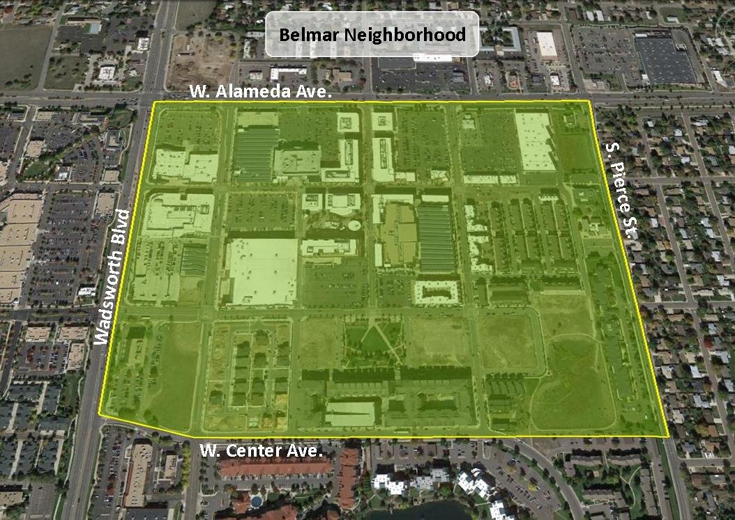

We will work with you to finalize the boundaries if your neighborhood is selected. If desired, attach a map to illustrate the boundaries. An example of an existing Sustainable Neighborhood (Belmar) is provided here:
North: W Alameda Ave, South: W Center Ave,
East: S Pierce St, West: Wadsworth Blvd

5. Neighborhood information
- Does your neighborhood have a formal neighborhood organization or homeowner’s association? (Having a formal neighborhood organization is not required.) If you’re unsure, visit https://www.lakewood.org/NeighborhoodOrganizations to see if there is a registered neighborhood organization in your area.)
- If your neighborhood does have an organization or association, please provide the organization name.
- If your neighborhood does have an organization or association, please explain if the association knows about this application and if/how the two groups will be connected (separate entities, partners, a subcommittee of the larger organization, etc).
- Describe the predominant type of housing in your neighborhood. (Primarily single-family homes or duplexes, primarily multi-family residences or townhomes, a mix of housing types, or you can also check “I’m not sure”.)
- Please share any distinguishing features about your neighborhood that you'd like us to know and that make your neighborhood unique (e.g., a lot of urban agriculture, historic preservation areas, existing community spaces like parks or schools, possible business or faith organization partners, etc.).
- Are there other characteristics that would make your neighborhood a good candidate for the Sustainable Neighborhoods Program?

6. Neighborhood Sustainability Project Ideas
Sustainable Neighborhood projects each fit into one or more of the five program goal areas:
- ENERGY: projects that promote energy efficiency in the neighborhood & encourage the use of renewable energy sources.
- AIR: projects that reduce emissions generated in the neighborhood and improve both outdoor and indoor air quality.
- WATER: projects that conserve water resources and improve water quality.
- LAND: projects that encourage stewardship and conservation of ecosystems and resources.
- PEOPLE: projects that enhance the social vitality of the neighborhood by encouraging community interaction, partnerships, and outreach programs.
You can download the “Goals, Target Areas, Suggested Projects” brochure for project ideas, or visit the existing Sustainable Neighborhood web pages to see what kind of projects are currently being completed. (www.SustainableNeighborhoodNetwork.org/Lakewood.) Feel free to adapt existing ideas or develop new ideas.
- Please share three project ideas you would like to pursue if your neighborhood is accepted into the Sustainable Neighborhoods Program. Project topics should be something you feel passionate about and that you believe would benefit your neighborhood. Descriptions should address the potential to positively impact your neighborhood and how the projects are customized to the neighborhood and its unique characteristics. Don’t worry too much about the logistics of HOW the project will get done, rather, focus instead on WHY this project is important to your team and to your neighborhood.
- If you have more than three projects ideas that you would like to let us know about, you may type them in a word document and upload them in the application.

You may already have more ideas than you can count, but if you need help, we have resources online to share project ideas. You can see a list of ideas in our Goals and Target Areas Suggested Projects brochure (www.SustainableNeighborhoodNetwork.org/information/goals-and-target-areas), or on each Sustainable Neighborhood’s website page at www.SustainableNeighborhoodNetwork.org/Lakewood.

7. Neighborhood engagement and reach
In addition to advancing sustainability goals, the Sustainable Neighborhoods Program is a great tool for strengthening community cohesion, increasing civic participation, and celebrating neighborhood diversity. This section of questions will help us understand how the Program will help build community, value diversity, and catalyze project development in your neighborhood.
  - Please select the sentence that best describes your neighborhood.
    - There is currently a moderate to high level of engagement from a diverse group of residents in the neighborhood.
    - There is currently community engagement from a few people in the neighborhood.
    - There is currently no community engagement in the neighborhood.
- Please share examples of the type of engagement or activities that currently occur in your neighborhood.
- Based on the level of engagement in your neighborhood, how will your team use the Program to leverage existing support to achieve sustainability goals and to serve as a catalyst for engagement, strengthen community cohesion and increase civic participation in your neighborhood?
- Please provide examples of how your team will work to be inclusive in all projects and events and encourage diversity of program participants. This may include but is not limited to engaging residents of diverse races and ethnicities, residents of varying ages and generations, residents who live in various types of housing, and residents of varying socioeconomic backgrounds.

8. neighborhood support
Neighborhood success in this program requires that residents work together to plan and implement initiatives. Strong applications include signatures of support from residents living in all areas of the neighborhood. A minimum of 20 signatures is recommended, and we encourage you to gather as many as you can. (If your neighborhood is accepted into the program, this list will serve as a starting point for publicity and engagement in activities.)
Instructions:
- Download the signature collection form from the program website as a template to collect neighborhood signatures.
- Scan or take a picture of the completed form(s).
- Upload completed form(s) in the online form or email to Sustainability@Lakewood.org.

